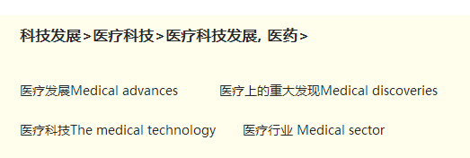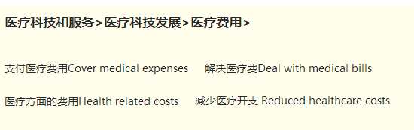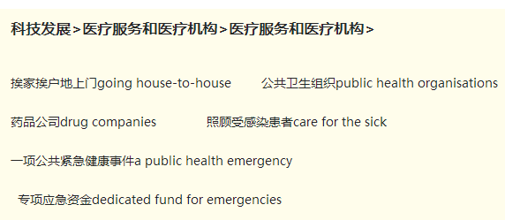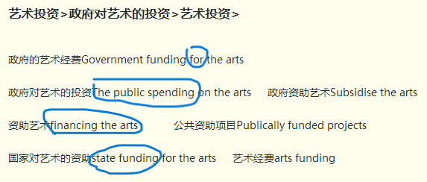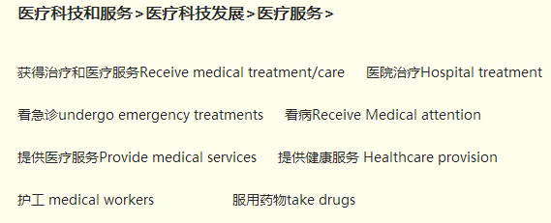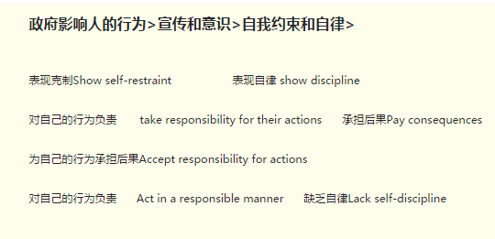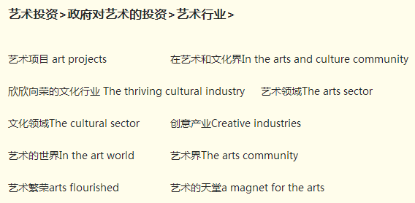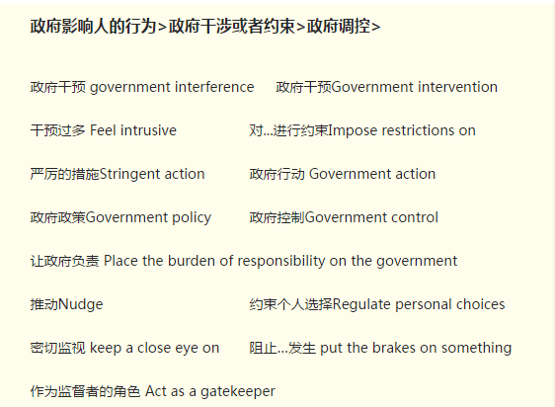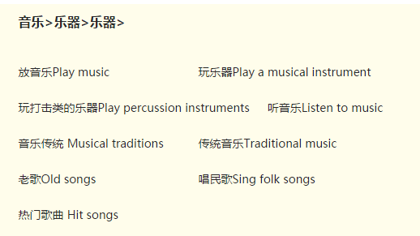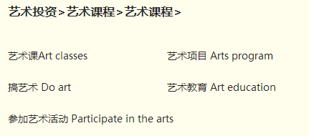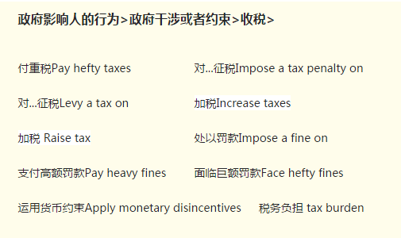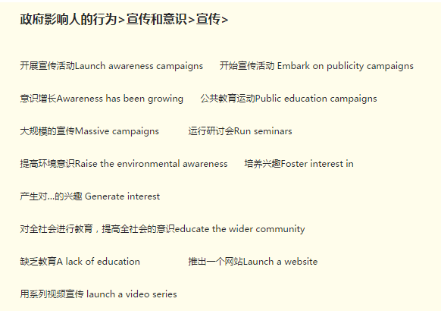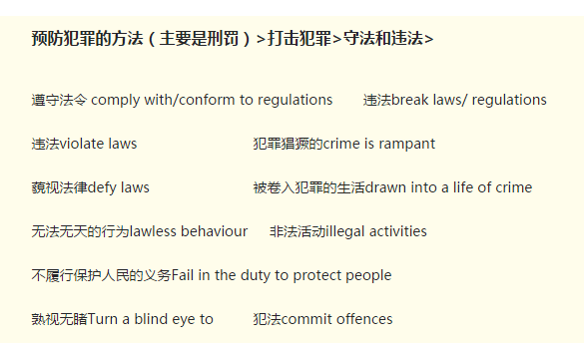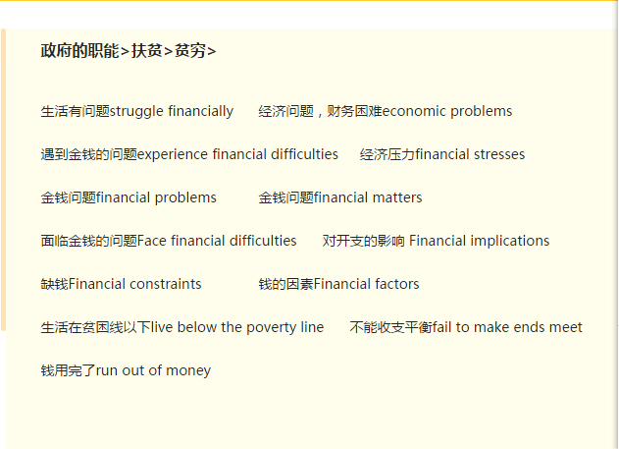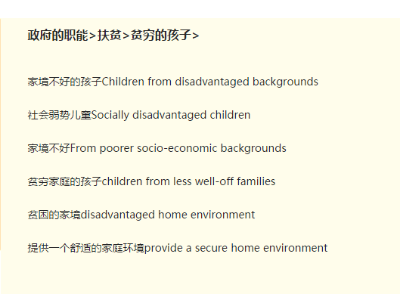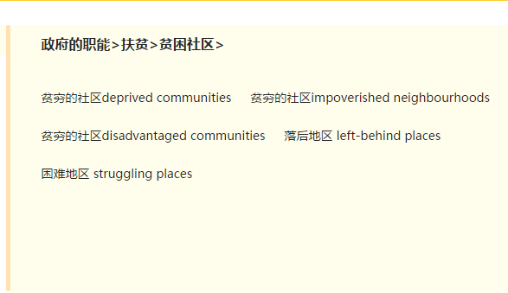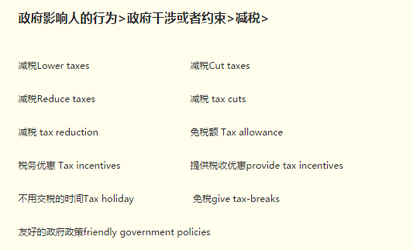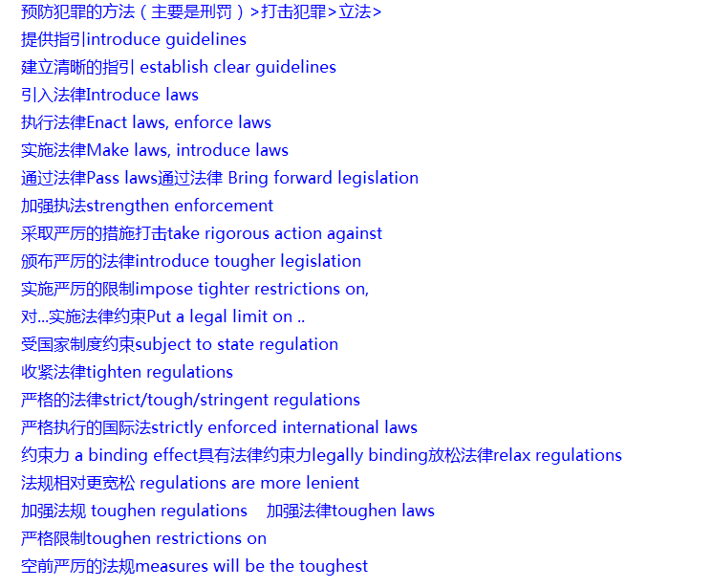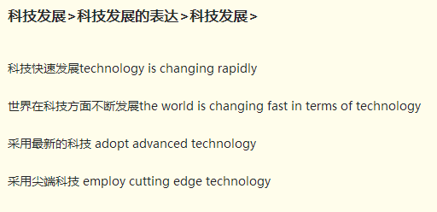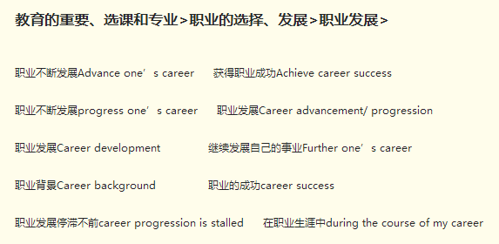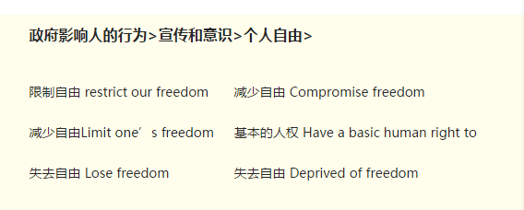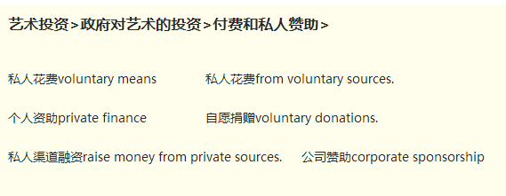

In summary

due to

so as to meet the demand via public services

the money may never reach the population due to the corruption（不加s）

disease不加s

making and enforcing laws

make an effort

hold the idea that； despite the fact that

This is because ... （不加that）

futhermore

the tax levied from high-income earners

tax=individual contributions to the runnig costs of the community are not only appropriate but essential because

invest tax money in[!] the provision提供 of public services and facilities which are indispensable of the daily lives of the public.

without tax revenue it is difficult for a country to function effectively

hard-earned money

food, and medical and educational aid is

the chances are that很可能

raises theissue of

a large proportion of their time

the applicatio of teamwork (group decision) as a management practice, which is touted as efficacious by professors of the business school

make bad choices

a source of innovation

earn a lot from...

freezing conditions

for deep analysis

On the other hand, theoretical knowledge should not be overvalued.

but I do not agree with the notion that the knowledge gained in university is of little value to one's career achievement.

flat, bonding, independence, decision-making, routine takss, (potentially gain enhanced) interpersonal skills, personal resources

their emotional pressures may be so badly handled that the relationship with their parents is affected and they do not see the value in maintaining close contact with family.

cope with challenges

get/receive advice

experience difficulties

can also (v.)

can be made exmpt from tuition fees

dearth of jobs

scarcity dificiency insufficiency

The total was close to 20% of the workforce

We must harness the skill and creativity of our workforce.

Men still outnumber women in the paid workforce.

disposal of refuse

modern offices become more and more mechanized

modern irrigation

minimize damage and avoid loss of

significance influence

alleviate stress

starvation

government revenue

manufacture goods

manufacture product

manufacture products

invest in infrastructure

provide infrastructure

build infrastructure

develop infrastructure

improve infrastructure

intensify magnify

community is used for less serious offenders

wrongdoer a delinquent person lawbreaker

more often than not

university accommodation, parental home, share flats with friends/flatmates

bonding with family (will suffer)

the length of lease

decision-making ability, managing the monthly budget, keepinga house

enter the workforce

which can prepare them for challenges

potentially gain enhanced interpersonal skills

people from all walks of life in different setting (joining some clubs, going to gym, attending parties and taking up a part-time job)

which is of value to

personal resources to draw upon, a network of contacts

combat the sense of lonliness

with their parents

maintain close contact

community service: cleaning streets, tending public gardens and removing graffiti

imposing prison sentences/ sending criminals to prison

prisons are over flowing and can't cope

punitive刑罚的 efforts

rehabilitation恢复 efforts

offender罪犯/lawbreaker

other approaches/methods

law-abiding守法的

when incarcerated在狱中

are disengaged from communities

foster

probation缓刑

the spur of the moment

repent后悔

corrective method; correct mistakes

deprive them of freedom

modify behaviour

complex nominal groups: the knowledge children can gain from these programmes

in ways that traditioinal approaches can not match

convery information

the number of hours devoted to ... will drop

soup opera

TV programmes

engage their interest

can be taken to refer ...

uphold维护 uphold some values which are critical to a harmonious society loyality, honesty and integrity

inhibit阻止 at least appear to inhibit social progress

laws tend to/prone to limit freedom supress creativity

censorship law (example)

voice their concerns

pinpoint and tackle some problems such as corruption and bureaucracy

impose harsh penalities to some business practices, such as making exaggerated claims

so as to

would-will: if, will; is-would: it would be difficult to keep a society running without laws

achieve very negative outcomes

fraudulent or violent activities

(involve) long-haul transportation, which relies on the use of different modes of transport, including airplanes and road transport

stagnant停滞不前的 market growth is stagnant

purchase; imported products/imported from overseas

natural endowment; the avaliability of cheap labour

is beneficial to

cost management/ control the cost of production

household goods; geographic locations and weather conditions

fill unmet needs

clothing, foodwear, bed linen and blankets

intensify the/fierce competition, put ... under pressure

high tariffs关税 the market distorted by tariffs

Within society, there is a growing gulf between rich and poor.柯林斯

are interwined

the accumulated body of

capitalize on

spark thoughts

develop-progress-promote

fund-invest-subsidize

be commited to do

cultural heritage

a wealth of

simply put

making it not surprising

Develop/improve competence

1. It is rife to maintain vanity. 保持虚荣心是很常见的2. The method is superior to the old one. 这个（教育）方法比另一个更好3. Doting parents cater to their children’s every wish. 宠溺的父母满足他们孩子的一切需求4. Impose rules and regulations on children. 给孩子们制定规则5. Learn by rote 死记硬背6. Peer pressure 同辈压力7. Youth crime/ juvenile delinquency is largely due to parental permissiveness. 青少年犯罪很大程度上是父母的放纵造成的再来个媒体类：1. The proliferation of the Internet 互联网的普及2. Fabricate evidence and distort the truth 捏造证据歪曲事实3. Outdated information 过时的信息4. Up-to-date Information 最新的信息5. Be inundated with obscene content充满不良内容6. Advertising is a form of modern art 广告是一种现代艺术7. Brand image 品牌形象8. Consumer culture 消费文化

He was engrossed in his job to the detriment of his health.

Children spend too much time on schoolwork, to the detriment of other activities.

These difficulties have been overcome without detriment to performance.

He ascribed his failure to bad luck.; We ascribe great importance to these policies.